Elongated Square Gyrobicupola

Definition
# Source: AI Source: Provided by: [Data Path: Persons Table -> ID Column: 1, Name_En Column: Motasem Essam] -> From: [ChatGPT] on [7/25/2026]
An Elongated Square Gyrobicupola is a convex polyhedron formed by joining two identical square cupolas to the opposite ends of an octagonal prism, with one cupola rotated by ${45}^{∘}$ relative to the other.
It is the 37th Johnson solid (J37). It is also known as:
- Miller's Solid
- Miller–Aškınuze Solid
- Pseudorhombicuboctahedron
- Gyrate Rhombicuboctahedron
It has 8 equilateral triangular faces and 18 square faces, giving a total of 26 faces.

Geometric Structure
# Source: AI Source: Provided by: [Data Path: Persons Table -> ID Column: 1, Name_En Column: Motasem Essam] -> From: [ChatGPT] on [7/25/2026]
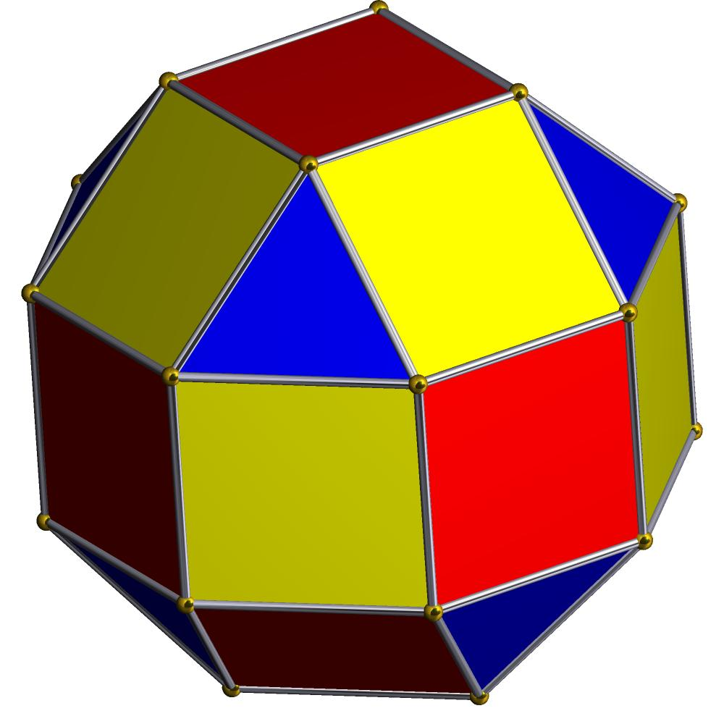
The solid consists of three main components:
- Upper Square Cupola: A square cupola attached to one end of the prism.
- Central Octagonal Prism: An octagonal prism connecting the two cupolas.
- Lower Square Cupola: A second square cupola attached to the opposite end, rotated ${45}^{∘}$ relative to the upper cupola.
The octagonal joining faces are internal and are not counted as external faces.

Face Composition
# Source: AI Source: Provided by: [Data Path: Persons Table -> ID Column: 1, Name_En Column: Motasem Essam] -> From: [ChatGPT] on [7/25/2026]
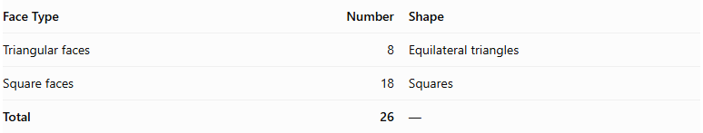
Face Type | Number | Shape
Triangular faces | 8 | Equilateral triangles
Square faces | 18 | Squares
Total | 26 | —
The 18 square faces comprise:
- 8 square faces from the two square cupolas.
- 8 lateral square faces from the octagonal prism.
- 2 opposite square faces at the ends of the solid.

Mathematical Properties
# Source: AI Source: Provided by: [Data Path: Persons Table -> ID Column: 1, Name_En Column: Motasem Essam] -> From: [ChatGPT] on [7/25/2026]
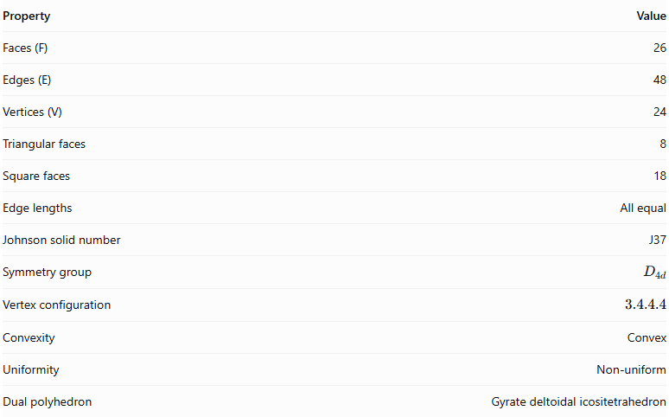
Property | Value
Faces (F) | 26
Edges (E) | 48
Vertices (V) | 24
Triangular faces | 8
Square faces | 18
Edge lengths | All equal
Johnson solid number | J37
Symmetry group | $$D_{4d}$$
Vertex configuration | $$3.4.4.4$$
Convexity | Convex
Uniformity | Non-uniform
Dual polyhedron | Gyrate deltoidal icositetrahedron
Euler's formula:
$$V-E+F=24-48+26=2$$

Surface Area
# Source: AI Source: Provided by: [Data Path: Persons Table -> ID Column: 1, Name_En Column: Motasem Essam] -> From: [ChatGPT] on [7/25/2026]
For edge length $a$:
$$S=8(\frac{\sqrt{3}}{4}a^{2})+18a^{2}$$
$$\boxed{S=(18+2\sqrt{3})a^{2}}$$
For unit edge length:
$$S≈21.4641$$

Volume
# Source: AI Source: Provided by: [Data Path: Persons Table -> ID Column: 1, Name_En Column: Motasem Essam] -> From: [ChatGPT] on [7/25/2026]
$$\boxed{V=\frac{12+10\sqrt{2}}{3}a^{3}}$$
For unit edge length:
$$V≈8.7140$$

Geometric Characteristics
# Source: AI Source: Provided by: [Data Path: Persons Table -> ID Column: 1, Name_En Column: Motasem Essam] -> From: [ChatGPT] on [7/25/2026]
- Convexity: It is a convex polyhedron.
- Face regularity: All faces are regular polygons: equilateral triangles and squares.
- Edge uniformity: All 48 edges have equal length.
- Vertex configuration: Every vertex has three square faces and one triangular face meeting around it, represented by $3.4.4.4$.
- Vertex distinction: Although all vertices have the same local face arrangement, they are not all equivalent under the solid's symmetries. There are two vertex classes: 8 vertices and 16 vertices.
- Symmetry: It has $D_{4d}$ symmetry, with a fourfold improper rotational symmetry axis.
- Uniformity: It is not an Archimedean solid because its vertices are not all equivalent under its symmetry group.
- Duality: Its dual is the Gyrate Deltoidal Icositetrahedron.

Construction of Elongated Square Gyrobicupola

Geometric Instruments Used
# Source: AI Source: Provided by: [Data Path: Persons Table -> ID Column: 1, Name_En Column: Motasem Essam] -> From: [ChatGPT] on [7/25/2026]
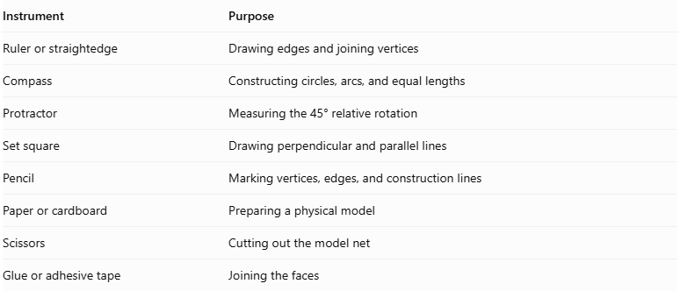
Instrument | Purpose
Ruler or straightedge | Drawing edges and joining vertices
Compass | Constructing circles, arcs, and equal lengths
Protractor | Measuring the 45° relative rotation
Set square | Drawing perpendicular and parallel lines
Pencil | Marking vertices, edges, and construction lines
Paper or cardboard | Preparing a physical model
Scissors | Cutting out the model net
Glue or adhesive tape | Joining the faces

Instrument-Based Construction Procedures

Construct the First Square Cupola
# Source: AI Source: Provided by: [Data Path: Persons Table -> ID Column: 1, Name_En Column: Motasem Essam] -> From: [ChatGPT] on [7/25/2026]
- Draw a regular octagon using a compass, ruler, and protractor.
- Construct a square top above the octagonal base according to the square-cupola arrangement.
- Construct eight alternating lateral faces:
- Four equilateral triangles.
- Four squares.
- Ensure that all edges have the required equal length.
- Check that the square top and lateral faces connect correctly to the octagonal base.

Construct the Second Square Cupola
# Source: AI Source: Provided by: [Data Path: Persons Table -> ID Column: 1, Name_En Column: Motasem Essam] -> From: [ChatGPT] on [7/25/2026]
- Draw another regular octagon congruent to the first.
- Construct a square top with matching dimensions.
- Construct four equilateral triangular faces and four square faces around the octagonal base.
- Ensure that the second cupola matches the first in dimensions and face arrangement.
- Keep the second cupola separate for the rotational adjustment.

Construct the Central Octagonal Prism
# Source: AI Source: Provided by: [Data Path: Persons Table -> ID Column: 1, Name_En Column: Motasem Essam] -> From: [ChatGPT] on [7/25/2026]
- Draw two congruent regular octagons.
- Place them parallel to one another, separated by a distance equal to the required prism height.
- Join corresponding vertices with eight lateral edges.
- Complete the eight lateral square faces.
- Ensure that the prism's octagonal bases match the larger bases of the two square cupolas.

Rotate the Second Cupola
# Source: AI Source: Provided by: [Data Path: Persons Table -> ID Column: 1, Name_En Column: Motasem Essam] -> From: [ChatGPT] on [7/25/2026]
- Identify the center of the lower octagonal base.
- Mark the required relative rotation:
$$α={45}^{°}$$
- Rotate the second square cupola by ${45}^{°}$ around the central axis.
- Keep the octagonal joining base congruent with the lower base of the prism.
- Check that the square top of the rotated cupola has the correct orientation relative to the upper square top.

Join the Three Components
# Source: AI Source: Provided by: [Data Path: Persons Table -> ID Column: 1, Name_En Column: Motasem Essam] -> From: [ChatGPT] on [7/25/2026]
- Attach the first square cupola to one octagonal base of the prism.
- Attach the rotated second square cupola to the opposite octagonal base.
- Match the octagonal boundaries and corresponding edges.
- Ensure that all component faces meet edge-to-edge without gaps or unintended overlaps.
- Treat both octagonal joining bases as internal surfaces.
- Verify that the completed exterior contains eight equilateral triangles and eighteen squares.

Complete the Solid Drawing
# Source: AI Source: Provided by: [Data Path: Persons Table -> ID Column: 1, Name_En Column: Motasem Essam] -> From: [ChatGPT] on [7/25/2026]
- Draw the upper and lower square regions.
- Complete the central band of square faces.
- Complete the eight triangular faces around the two cupolas.
- Use solid lines for visible edges.
- Use dashed lines for hidden edges when necessary.
- Check the final face, edge, and vertex counts.
Construction restriction: This procedure uses geometric instruments, angle measurements, and geometric relationships. It does not use coordinate-based construction.

Related Geometric Solids
# Source: AI Source: Provided by: [Data Path: Persons Table -> ID Column: 1, Name_En Column: Motasem Essam] -> From: [ChatGPT] on [7/25/2026]
- Square Cupola (J4): The component solid used at both ends.
- Square Gyrobicupola (J29): The corresponding bicupola without the central octagonal prism.
- Elongated Square Orthobicupola: A related elongated solid with aligned square cupolas.
- Small Rhombicuboctahedron: A uniform Archimedean solid with the same face composition, but a different vertex arrangement.
- Gyrate Deltoidal Icositetrahedron: The dual polyhedron of the Elongated Square Gyrobicupola.

Main Classification
# Source: AI Source: Provided by: [Data Path: Persons Table -> ID Column: 1, Name_En Column: Motasem Essam] -> From: [ChatGPT] on [7/25/2026]
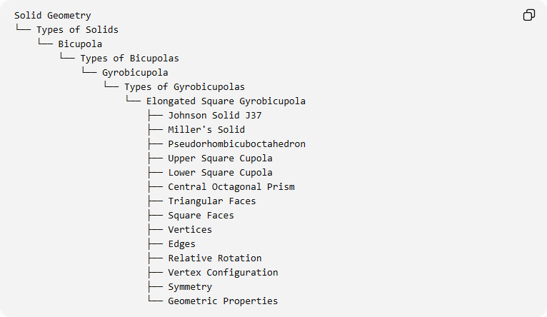
Solid Geometry
└── Types of Solids
└── Bicupola
└── Types of Bicupolas
└── Gyrobicupola
└── Types of Gyrobicupolas
└── Elongated Square Gyrobicupola
├── Johnson Solid J37
├── Miller's Solid
├── Pseudorhombicuboctahedron
├── Upper Square Cupola
├── Lower Square Cupola
├── Central Octagonal Prism
├── Triangular Faces
├── Square Faces
├── Vertices
├── Edges
├── Relative Rotation
├── Vertex Configuration
├── Symmetry
└── Geometric Properties

Important Distinction
# Source: AI Source: Provided by: [Data Path: Persons Table -> ID Column: 1, Name_En Column: Motasem Essam] -> From: [ChatGPT] on [7/25/2026]
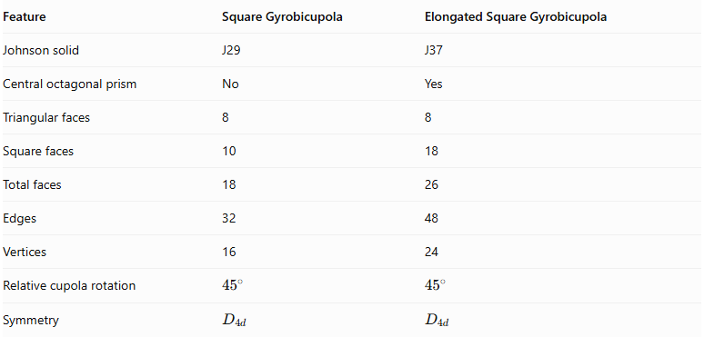
Feature | Square Gyrobicupola | Elongated Square Gyrobicupola
Johnson solid | J29 | J37
Central octagonal prism | No | Yes
Triangular faces | 8 | 8
Square faces | 10 | 18
Total faces | 18 | 26
Edges | 32 | 48
Vertices | 16 | 24
Relative cupola rotation | $${45}^{∘}$$ | $${45}^{∘}$$
Symmetry | $$D_{4d}$$ | $$D_{4d}$$
The elongated version has an octagonal prism inserted between the two square cupolas, increasing its number of square faces, edges, and vertices.

Key Points
# Source: AI Source: Provided by: [Data Path: Persons Table -> ID Column: 1, Name_En Column: Motasem Essam] -> From: [ChatGPT] on [7/25/2026]
- The Elongated Square Gyrobicupola is Johnson solid J37.
- It is constructed from two square cupolas and one central octagonal prism.
- One cupola is rotated ${45}^{∘}$ relative to the other.
- It has 8 equilateral triangular faces and 18 square faces.
- It has 26 faces, 48 edges, and 24 vertices.
- It is also known as Miller's Solid or the Pseudorhombicuboctahedron.
- It is not a true Archimedean solid because its vertices are not all equivalent.

Conclusion
# Source: AI Source: Provided by: [Data Path: Persons Table -> ID Column: 1, Name_En Column: Motasem Essam] -> From: [ChatGPT] on [7/25/2026]
The Elongated Square Gyrobicupola is a convex Johnson solid formed by connecting two rotated square cupolas with an octagonal prism. Its 26 faces, 48 edges, and 24 vertices give it a distinctive structure related to the small rhombicuboctahedron, but with a different vertex arrangement.

